ASSIGNMENT

A. Assignment Information
Department: | (AI & ML)
Programme: | BTECH AIML
Course Code & Course Name | CSA0702 - Computer Networks
Academic Year / Batch | 2024
Faculty Name | Dr. R. Senthamil Selvan
Assignment Title | Design and Implementation of a VLAN-Based Enterprise LAN Using Cisco Packet Tracer
Date of Issue | 31 August 2026
Date of Submission | 1 September 2026
Maximum Marks | 100
Course Outcome(s) - CO | CO4: Design and configure switched/VLAN-based LANs and implement inter-VLAN routing to meet enterprise networking requirements.
Bloom's Taxonomy Level | L3 - Apply / L4 - Analyze
SDG Mapping (SDG 1-17) | SDG 9: Industry, Innovation and Infrastructure
Industry / Societal Relevance | VLAN segmentation is widely used in real enterprise, campus, and institutional networks to isolate departments, improve security, and manage broadcast traffic efficiently.

Problem Statement and Problem Formulation
The objective of this assignment is to develop an enterprise LAN in Cisco Packet Tracer where users are grouped according to their departments. Administration, Faculty, Students, and Guests are placed in individual VLANs so that network traffic is organized into separate logical groups. The network is configured with suitable addressing, switch connections, trunk links, and inter-VLAN routing to provide communication where required.

Objective and Expected Outcomes

Objective
To design a structured enterprise network using VLAN technology for departmental separation and efficient communication.

Expected Outcomes
- Create four departmental VLANs.
- Allocate suitable IP networks to each VLAN.
- Connect end devices to their assigned VLANs.
- Configure trunk communication between network devices.
- Establish communication between different VLANs.
- Check the network operation using connectivity tests.

Requirements, Constraints and Assumptions

Requirements
The proposed network consists of one router, one multilayer switch, four access switches, and eight PCs. Each department requires a dedicated VLAN, subnet, and gateway.

Constraints
The complete network must be developed and tested in Cisco Packet Tracer. The specified topology and Router-on-a-Stick approach must be maintained.

Assumptions
Each PC is assumed to have a valid static IP address and the correct default gateway. Network devices are assumed to support VLAN and IEEE 802.1Q trunk configurations.

Application of Relevant Course Knowledge / Concepts
The implementation makes use of the following networking concepts:
- Virtual Local Area Networks
- Logical network segmentation
- IPv4 addressing
- Subnetting
- Ethernet switching
- Access port configuration
- Trunk port configuration
- IEEE 802.1Q encapsulation
- Inter-VLAN routing
- Router sub-interfaces
- ICMP-based ping testing

Design / Proposed Solution / Methodology
A hierarchical departmental network is designed using a central multilayer switch connected to four departmental access switches. Each access switch serves one department and connects two PCs. The router is connected to the central switch through a trunk link.
The four VLANs are identified as follows:
VLAN | Department
10 | Administration
20 | Faculty
30 | Students
40 | Guests
Each VLAN receives an independent /24 network. Router sub-interfaces are configured as gateways for the corresponding VLANs. After completing the configuration, both local and inter-VLAN connectivity are tested.

Algorithm / Pseudocode
START

Design the enterprise LAN topology

Place router, multilayer switch,
four access switches and eight PCs

Connect all network devices

Create four departmental VLANs

Assign VLAN 10 to Administration
Assign VLAN 20 to Faculty
Assign VLAN 30 to Students
Assign VLAN 40 to Guests

Configure departmental switch ports

Configure required trunk links

Configure router sub-interfaces

Assign gateway addresses

Configure IP addresses on PCs

Check VLAN and trunk status

Perform connectivity tests

IF communication succeeds
Record successful result
ELSE
Identify and correct configuration errors
END IF

STOP

Implementation / Environment / Tools Used
The proposed network is implemented and tested using Cisco Packet Tracer. The simulation environment provides the required Cisco networking devices and allows the configuration to be observed before deployment in a physical network.

Devices Used
- Router – R1
- Multilayer Switch – S1
- Access Switches – S2, S3, S4, S5
- Eight PCs
- Ethernet connections

VLAN Configuration
VLAN ID | Department | Network
10 | Administration | 192.168.10.0/24
20 | Faculty | 192.168.20.0/24
30 | Students | 192.168.30.0/24
40 | Guests | 192.168.40.0/24

IP Addressing Scheme
Device | VLAN | IP Address | Gateway
PC-A1 | 10 | 192.168.10.10 | 192.168.10.1
PC-A2 | 10 | 192.168.10.11 | 192.168.10.1
PC-F1 | 20 | 192.168.20.10 | 192.168.20.1
PC-F2 | 20 | 192.168.20.11 | 192.168.20.1
PC-S1 | 30 | 192.168.30.10 | 192.168.30.1
PC-S2 | 30 | 192.168.30.11 | 192.168.30.1
PC-G1 | 40 | 192.168.40.10 | 192.168.40.1
PC-G2 | 40 | 192.168.40.11 | 192.168.40.1

Router Gateway Addresses

VLAN | Gateway
VLAN 10 | 192.168.10.1
VLAN 20 | 192.168.20.1
VLAN 30 | 192.168.30.1
VLAN 40 | 192.168.40.1

Test Cases and Expected/Actual Results

Test Case | Expected Result | Actual Result
PC-A1 → PC-A2 | Successful | Record after testing
PC-F1 → PC-F2 | Successful | Record after testing
PC-A1 → PC-F1 | Successful inter-VLAN communication | Record after testing
PC-A1 → PC-S1 | Successful inter-VLAN communication | Record after testing
PC-A1 → PC-G1 | Successful inter-VLAN communication | Record after testing
VLAN verification | Four VLANs visible | Record after testing
Trunk verification | Trunk link active | Record after testing

Execution Screenshots / Outputs
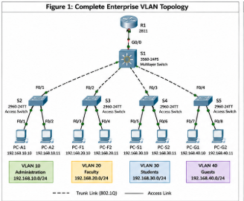
Figure 1: Complete enterprise VLAN topology
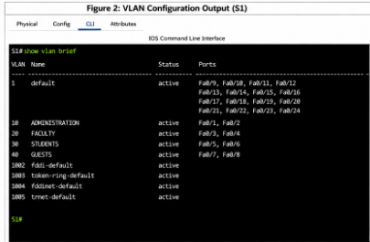
Figure 2: VLAN configuration output
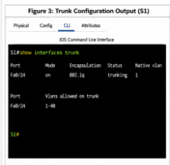
Figure 3: Trunk configuration output

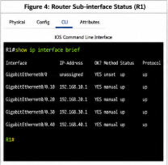
Figure 4: Router sub-interface status

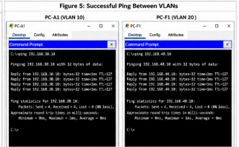
Figure 5: Successful ping between VLANs

Results and Validation
The completed network is validated by checking VLAN membership, trunk operation, router gateway interfaces, and end-to-end connectivity. Successful ping responses between different departmental networks demonstrate that the configured routing path is operational. The verification results are recorded using Cisco Packet Tracer command-line outputs and PC connectivity tests.

Analysis, Comparison, Trade-offs and Justification
Inter-VLAN communication can be implemented using either Router-on-a-Stick or SVI-based routing.

Router-on-a-Stick
In this approach, one router interface is divided into multiple logical sub-interfaces. Each sub-interface provides routing for one VLAN.
Benefits:
- Easy to understand
- Simple to configure
- Appropriate for a small network
- Uses fewer routing interfaces

SVI-Based Routing
SVI routing uses the Layer 3 switching capability of a multilayer switch. Each VLAN can have its own switched virtual interface.
Benefits:
- Faster internal routing
- Better scalability
- Suitable for high-traffic enterprise networks

Final Decision
Router-on-a-Stick is selected for this implementation because it provides a straightforward way to demonstrate inter-VLAN routing and meets the specified requirements of the assignment.

Broader Considerations / SDG Relevance

SDG 4 – Quality Education
The activity provides hands-on experience in network configuration and develops practical technical skills through simulation.

SDG 9 – Industry, Innovation and Infrastructure
The project demonstrates the design of organized and scalable network infrastructure using VLAN technology.

SDG 11 – Sustainable Cities and Communities
The same type of logical network segmentation can be applied to connected campuses, smart buildings, and other digitally connected environments.

Conclusion, Limitations and Possible Improvements

Conclusion
The proposed enterprise LAN provides separate logical networks for Administration, Faculty, Students, and Guests. VLANs, IP addressing, trunking, and inter-VLAN routing are incorporated to create an organized network architecture. The final configuration can be validated through VLAN status, trunk status, and ping-based connectivity tests.

Limitations
The simulation represents a relatively small network and does not include advanced enterprise features such as redundancy, firewall policies, or detailed access control.

Possible Improvements
- Configure ACLs for departmental access control.
- Restrict Guest access to internal resources.
- Introduce DHCP services.
- Implement SVI routing on the multilayer switch.
- Add redundant links and devices.
- Expand the network for additional departments.

Individual Contribution
The work includes network topology design, VLAN planning, IP addressing, switch configuration, router configuration, inter-VLAN routing, connectivity testing, troubleshooting, and preparation of the assignment documentation.

References
- Cisco Networking Academy – VLAN and Inter-VLAN Routing concepts.
- Cisco Packet Tracer – Network simulation environment.
- IEEE 802.1Q – VLAN tagging and trunking standard.
- CSA0702 – Computer Networks course materials.

One-Page Individual Reflection
This assignment helped me understand how VLAN technology can be used to organize a network into separate departmental groups. Instead of treating all devices as part of one common network, I learned how Administration, Faculty, Students, and Guests can be assigned different VLANs and IP networks.
The practical implementation improved my understanding of switch port configuration, trunking, IP addressing, and router sub-interfaces. Working with Cisco Packet Tracer also helped me understand the relationship between the physical topology and the logical configuration of a network.
I learned that successful communication depends on several configurations working together. VLAN membership, IP addresses, default gateways, trunk links, and router sub-interfaces must all be correctly configured. Verification commands and ping tests are therefore important for identifying configuration problems.
The project also showed me how VLANs can contribute to better network organization and security. Separating Guest users from other departments provides a foundation for applying additional security policies in a real enterprise network.
Overall, this assignment improved my practical networking skills and gave me experience in designing, configuring, testing, and analyzing an enterprise LAN using Cisco Packet Tracer.

